# **CS 1101-01: Programming Assignment Unit 4**

Godknows Egi

Bachelor of Science in Computer Science, Uopeople

CS 1101-01 - AY2024-T3: Functions and Return Values

Bianca Gilyot

February 28th , 2024

**Part 1**

You work as a software developer in a company that creates custom software solutions for various clients. Your company has been approached by an educational client who wants to develop a function that calculates the length of the hypotenuse of a right triangle given the lengths of the other two legs as arguments. Your manager has instructed you to use incremental development to create the necessary function and document each stage of the development process. After completing the final stage of development, you have to test the function with different arguments and record the outputs in your Learning Journal.

Include all of the following in your submission:

1. An explanation of each stage of development, including code and any test input and output.
2. The output of hypotenuse(3,4).
3. The output of two additional calls to hypotenuse with different arguments.

**Part 2**

You are a software developer who wants to establish yourself as a skilled and versatile programmer. To achieve this, you have decided to create a work portfolio that

showcases your ability to develop custom software solutions. This portfolio will be your gateway to attract potential clients and establish yourself as a freelancer.

As part of your portfolio, you plan to create your own function that does some useful computation using an incremental development approach that will demonstrate your programming skills and problem-solving abilities. You will document each stage of the development process, including the code and any test input and output in your Programming Assignment.

**Solution for Part 1**

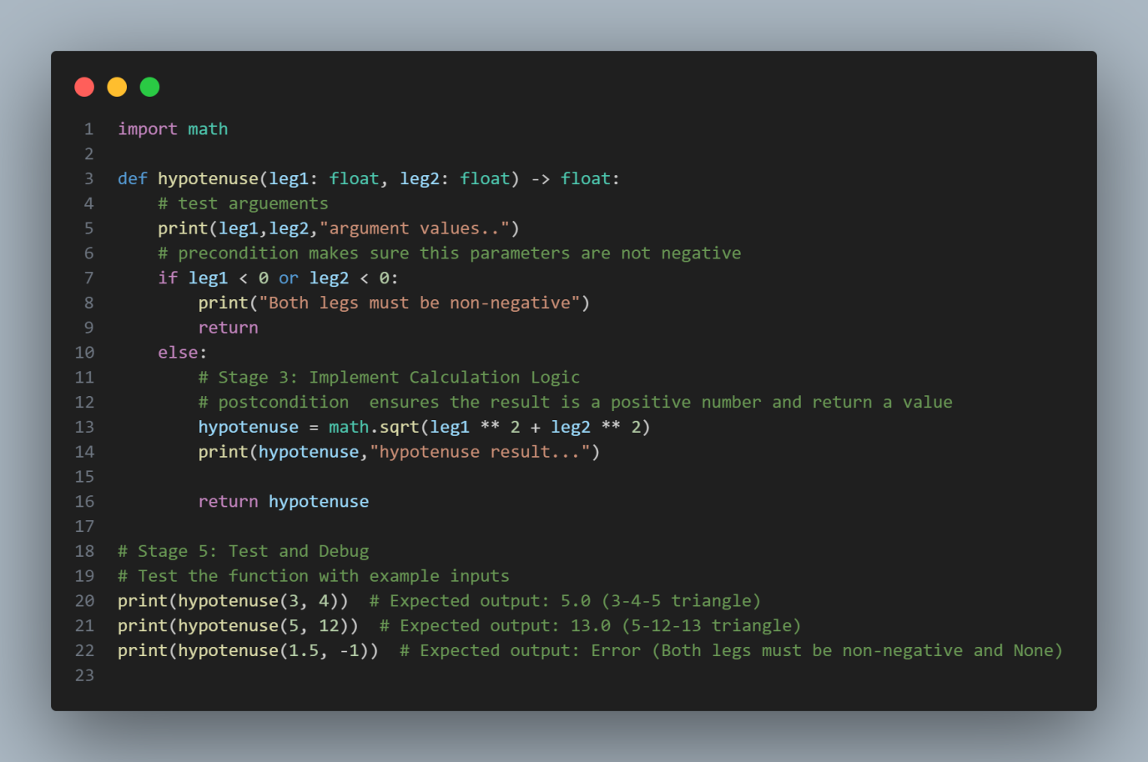

*Code for Question P1*

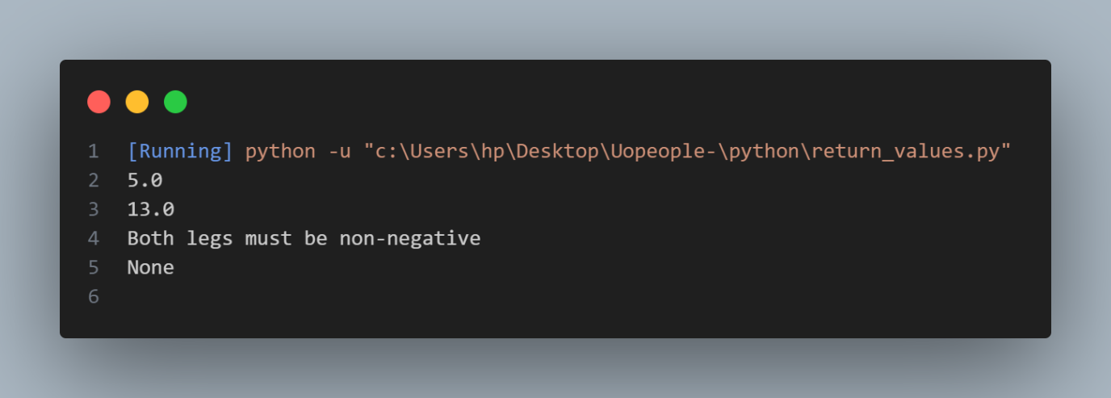

*Output for Question P1*

This function calculates the length of the hypotenuse of a right triangle given the lengths of the other two legs as a parameter, following the incremental development patterns as follows:

* I created a function hypotenuse that accepts parameter (length of the two legs of a right triangle).
* Secondly I have added a print statement before my preconditions to rule out the possibility and check accuracy of the parameter as explained on Downey, A. (2015,). Think Python: How to think like a computer scientist ,*Chapter 6 - Fruitful functions (pp. 6.9)*
* The preconditional checks to ensure params are non-negative numbers, if the preconditions requirement are not met,Then the function return
* A Print statement before my postcondition to make the flow of execution more visible

**Solution for Part 2**

This is a function that performs basic arithmetic operations on two numbers. The function will take three argument as input two numbers and an operator (+, -, *, /) and return the result of the operation, following the incremental development approach

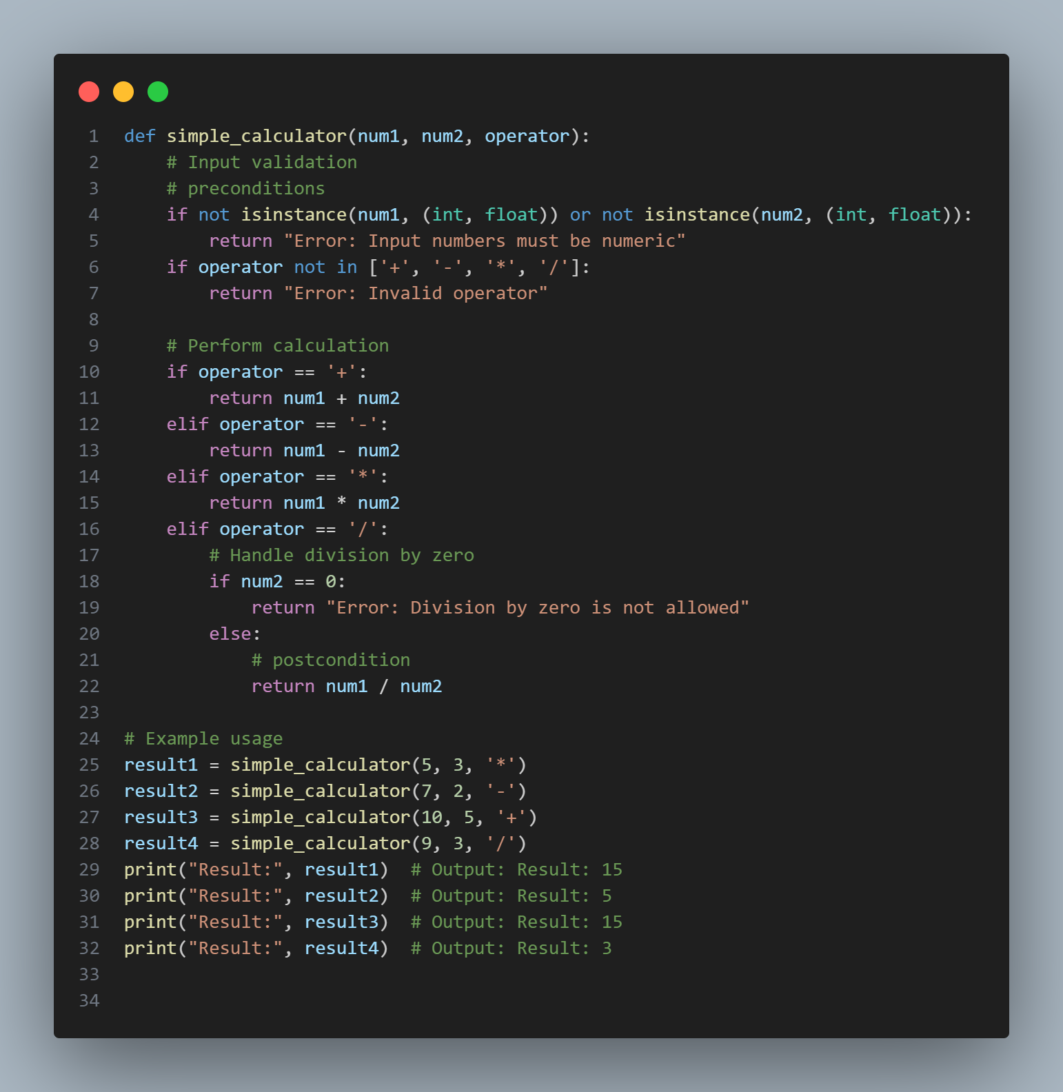

*Code for Question P2*

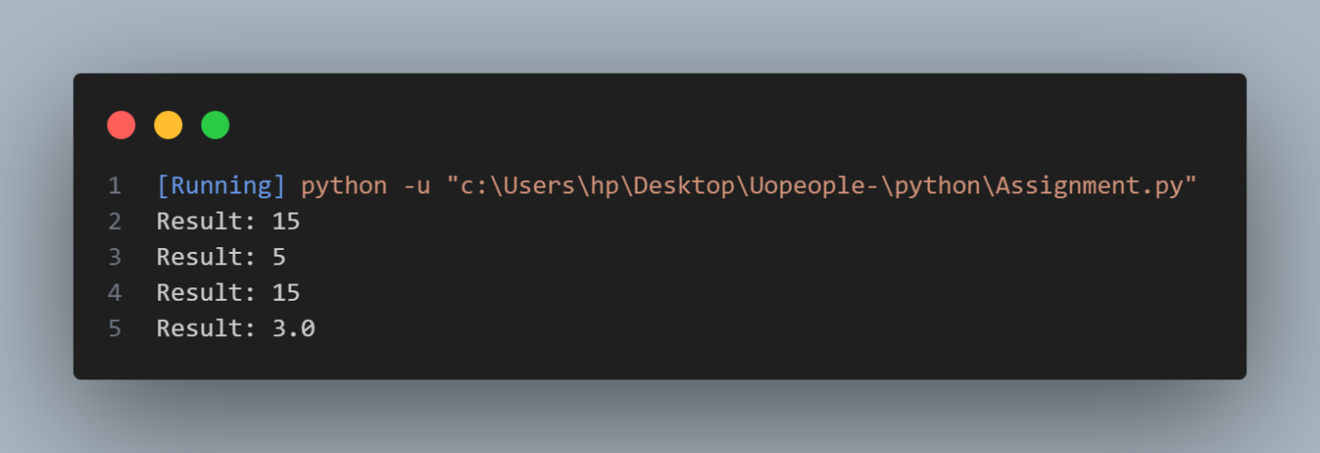

*Code output for Question P2*

This function takes in argument of two number and one operator, The operator justifies the method of the function computation, Secondly I added a precondition to make sure the operands are numeric value, follow by the operators, I added my operator in a list so that my preconditions can check if the operator params is valid or not. Thirdly I added a chained conditional statement to check for the operator that matches the operator argument and handle the computations based on the match and return the result of the evaluated expression

**References**

Downey, A. (2015,). Think Python: How to think like a computer scientist ,*Chapter 1 -Fruitful functions (pp. 6.9)*

<https://greenteapress.com/thinkpython2/thinkpython2.pdf>